1. Create an HTML file (e.g. first_page.html) that specifies a page that contains a heading

and two paragraphs of text. Use the HTML tags <h1>,</h1>,<p> and </p>. Add an image

to your web page. As an image, you can use any .jpg or .png file.

<!DOCTYPE html>

<html lang="en">

  <head>

    <meta charset="UTF-8" />

    <meta http-equiv="X-UA-Compatible" content="IE=edge" />

    <meta name="viewport" content="width=device-width, initial-scale=1.0" />

    <title>First Page</title>

    <style>

      h1 {

        color: blue;

      }

      img {

        max-width: 900px;

      }

    </style>

  </head>

  <body>

    <img src="./Sachin-Tendulkar.jpg" />

    <h1>Sachin Ramesh Tendulkar</h1>

    <p>

      Born (24 April 1973) is an Indian former international cricketer who

      captained the Indian national team. He is regarded as one of the greatest

      batsmen in the history of cricket. He is the all-time highest run-scorer

      in both ODI and Test cricket with more than 18,000 runs and 15,000 runs,

      respectively.He also holds the record for receiving the most

      man-of-the-match awards in international cricket.Sachin was a Member of

      Parliament, Rajya Sabha by nomination from 2012 to 2018.

    </p>

    <p>

      Tendulkar took up cricket at the age of eleven, made his Test match debut

      on 15 November 1989 against Pakistan in Karachi at the age of sixteen, and

      went on to represent Mumbai domestically and India internationally for

      over 24 years. In 2002, halfway through his career, Wisden ranked him the

      second-greatest Test batsman of all time, behind Don Bradman, and the

      second-greatest ODI batsman of all time, behind Viv Richards.The same

      year, Tendulkar was a part of the team that was one of the joint-winners

      of the 2002 ICC Champions Trophy. Later in his career, Tendulkar was part

      of the Indian team that won the 2011 Cricket World Cup, his first win in

      six World Cup appearances for India. He had previously been named "Player

      of the Tournament" at the 2003 World Cup.

    </p>

  </body>

</html>

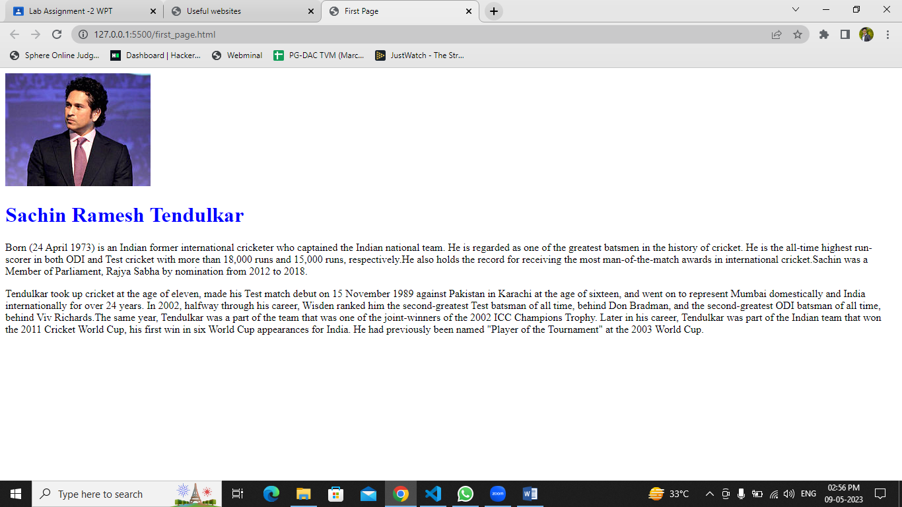

2. Write HTML code to create following webpage.

a. Apply Heading 3 for the text 'List of Useful Websites'. Insert a horizontal line after

List of Useful Websites heading. Add hyperlinks to these.

• Wikipedia

• Google

• Yahoo

<!DOCTYPE html>

<html lang="en">

  <head>

    <meta charset="UTF-8" />

    <meta http-equiv="X-UA-Compatible" content="IE=edge" />

    <meta name="viewport" content="width=device-width, initial-scale=1.0" />

    <title>Useful websites</title>

    <style>

      a {

        text-decoration-style: none;

        text-decoration: none;

      }

    </style>

  </head>

  <body>

    <h3>List of Useful Websites</h3>

    <hr />

    <ul>

      <li><a href="https://www.wikipedia.org/">Wikipedia</a></li>

      <li><a href="https://www.google.com/">Google</a></li>

      <li><a href="https://in.search.yahoo.com/">Yahoo</a></li>

    </ul>

  </body>

</html>

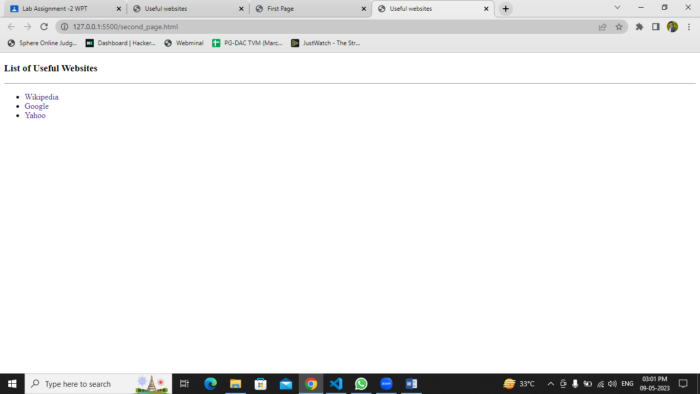

3. Create a registration page and a resume page.

a. Create a link in registration page with the name Resume and user should be Navigated to resume page.

b. Define a link to move back to registration page.

c. Apply the possible styling using CSS.

Registration page

<!DOCTYPE html>

<html lang="en">

  <head>

    <meta charset="UTF-8" />

    <meta http-equiv="X-UA-Compatible" content="IE=edge" />

    <meta name="viewport" content="width=device-width, initial-scale=1.0" />

    <title>Registration</title>

    <style>

      body {

        background-color: #787aff;

        text-align: center;

      }

      input {

        padding: 1px;

        margin-top: 10px;

        padding: 5px;

      }

      div {

        border: 2px solid black;

        border-radius: 5px;

        box-sizing: border-box solid;

        max-height: 400px;

        text-align: center;

      }

    </style>

  </head>

  <body>

    <h3>Registration Page</h3>

    <div>

      <input type="text" placeholder="Enter Your name" />

      <br />

      <input type="email" placeholder="Enter Email id" />

      <br />

      <input type="password" placeholder="Enter new password" />

      <br />

      Select Gender

      <input type="radio" name="Male" id="" />Male

      <input type="radio" name="Female" id="" />Female

      <input type="radio" name="other" id="" />Other <br /><br />

      <input type="button" value="Submit" />

      <br />

      <a href="./resume.html">Resume</a>

    </div>

  </body>

</html>

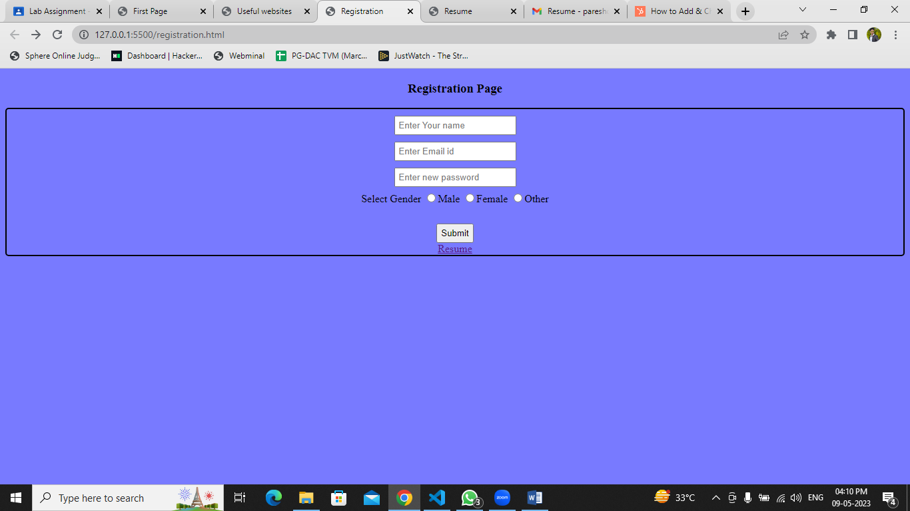

Resume Page

<!DOCTYPE html>

<html lang="en">

  <head>

    <meta charset="UTF-8" />

    <meta http-equiv="X-UA-Compatible" content="IE=edge" />

    <meta name="viewport" content="width=device-width, initial-scale=1.0" />

    <title>Resume</title>

    <style>

      body {

        background-color: #dbf9fc;

      }

      h {

        gap: 1px;

        text-align: justify;

      }

      h1 {

        text-decoration: underline rgb(3, 215, 243);

        text-align: center;

      }

      h3 {

        text-decoration: underline rgb(0, 0, 0);

      }

      #info {

        text-align: right;

      }

      #header {

        background-color: rgba(51, 222, 228, 0.356);

      }

    </style>

  </head>

  <body>

    <div id="header">

      <h1>Paresh Dhopat</h1>

      <div id="info">

        <h4 style="text-align: center">Email : pareshdhopat12@gmail.com</h4>

        <h4 style="text-align: center">Contact : 8097543222</h4>

        <h4 style="text-align: center">Location : Mumbai</h4>

      </div>

    </div>

    <hr />

    <h3>Objective</h3>

    <p>

      To become a successful expert in the field of Information Technology by

      channelizing my technical knowledge and skills to ensure personal and

      professional growth and to contribute to the prosperity of the

      organization.

    </p>

    <hr />

    <h3>Education</h3>

    <h4>Bachelor of Engineering (B.E) Computer Science & Engineering</h4>

    <p style="width: auto">St John College of Engineering and Technology</p>

    <p>Duration : 2016-2019 CGPA: 6.50/10</p>

    <h4>Diploma, Computer Science & Engineering</h4>

    <p>Shri Bhagubhai Mafatlal Polytechnic</p>

    <p>Duration 2012 - 2016 Percentage: 60.27%</p>

    <h4>Secondary (X)</h4>

    <p>Vidyanidhi Vrajlal Parekh High School (SSC Board)</p>

    <p>Year of completion: 2012 Percentage: 76.91%</p>

    <hr />

    <h3>Projects</h3>

    <h4>Voice Bot for Agricultural</h4>

    <p>Duration Jan 2019 - Apr 2019</p>

    <p>

      Farmers are not aware of the new emerging technologies and techniques So

      VoiceBot will help to increase their knowledge. We have built a system

      where the framers can resolve their queries about agriculture by using

      their phones.

    </p>

    <h4>Voice Recognition System</h4>

    <p>Duration Jan 2016 - Apr 2016</p>

    <p>

      This Software allows user to use their voice to control the computer. For

      example, for a task to run a particular file, we simply say "run

      (filename)". The software will automatically detect the file with that

      name and do the task mentioned.

    </p>

    <hr />

    <h3>Skills</h3>

    <ul>

      <li>Java</li>

      <li>HTML</li>

      <li>DBMS</li>

      <li>React Js</li>

      <li>node Js</li>

    </ul>

    <h3>Declaration</h3>

    <p>

      I hereby confirm and verify all the facts mentioned above and I hold the

      responsibility of their authenticity and correctness.

    </p>

    <h6 style="text-align: right">Thank you</h6>

    <h6 style="text-align: right">Paresh Dhopat</h6>

    <a href="./registration.html">Move back to registration</a>

  </body>

</html>

